Save the Habitat
Missouri NWTF State Chapter
Strategic Plan
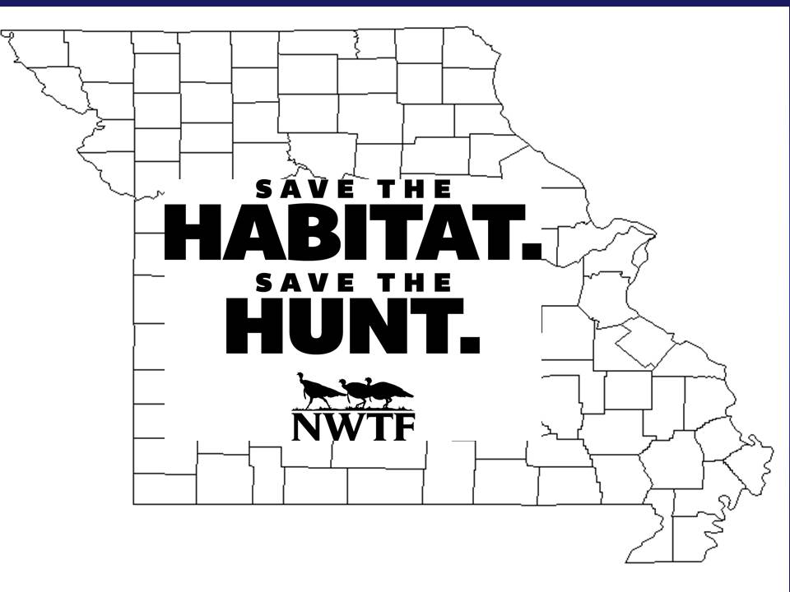

Table of Contents

Diagram of Strategic Plan 3

Habitat Enhancement Objectives and Strategies 4
Objectives 4
Strategies 4&5

Access Enhancement Objectives and Strategies 5
Objectives 5
Strategies 5

Hunt Enhancement Objectives and Strategies 5
Objectives 5
Strategies 6

Figure 1. Map of Missouri NWTF Focal Landscapes 7

Values: The MO-NWTF values ethical hunting, opening access to hunting, and educating others about hunting

Vision: More turkeys, More places to hunt, Preserving the hunt
Mission: The NWTF is dedicated to the conservation of the Wild Turkey and the Preservation of our hunting heritage.
National Goals: 4 Million Acres; 1.5 Million Hunters; 500,000 Access Acres

Strategic Hunt Issues
for the Future in Missouri
We need more hunting heritage events and need to transform existing ones to create hunters of all ages, not just introduce youth to shooting

Strategic Access Issues for the Future
Although Missouri has 1.6 million acres of national forest as well as conservation areas scattered throughout the state, all of this land only equates to 7% of our land base. Additional public access areas are needed as we grow our hunters numbers.
Strategic Habitat Conservation Issues
for the Future in Missouri
Forest Quality – Oak age class, composition shift, invasive species, savanna
Grassland Quantity – Managing existing grasslands and converting cool season grasses to native warm season grass

Create 20,300 New Hunters
- Expand Mentored Hunting
- Support Firearms Safety Training

Improve Public Access by 4,000 Acres
- Open closed lands – 400 acres/year
- Support new MDC access program
400,000 Acres Conserved/Enhanced
- Grasslands – 1,800 acres/year
- Open Woodlands – 1,200 acres/year
- Seed Program – 6,000 acres /year
- Equipment for Pvt & Pub Lands – 31,000 ac/yr

- Increase Super Fund and secure 5:1 Match
- Seek Focal Landscape Grants
- Expand Seed Program
  - Increase use of conservation seed program
  - Recruit more volunteers to house and facilitate drop point
  - Advertise Seed Program better
- Stewardship Contracting with Mark Twain
- Improve partnerships with other NGO’s
- Open existing lands to any levels of hunting
  - Conservancy lands - TNC
  - Public lands – Corp of Engineers, Parks , SNAs. Limited access for special hunts
  - Encourage/promote expansion of urban hunting opportunities for deer hunting

- Remove barriers to Firearms Safety
- Recruit firearm safety instructors to Committees
- Each Chapter host a field day
- Coordinate with state agency and Hunter Education Program to link classes more seamlessly with mentored hunting opportunities
- Expand/Increase Mentored Hunts
- Youth, Family, WITO, etc.
- Expand/improve existing dove hunting program
- Cooperation with other NGO’s
- Work with NASP, MHSCL, 4H, etc. Marketing mentored hunts directly to kids
- Create a web-based clearing house linking new hunters with available mentors
- Create a HRR Calendar for all seasons, hunts, clinics, safety clinics, shows
- Expand urban deer hunting opportunities

Conduct annual review as part of annual Super Fund project meeting

Conduct annual review as part of annual Super Fund project meeting

Conduct annual review as part of annual Super Fund project meeting

Habitat Enhancement Objectives and Strategies
These overarching habitat enhancement objectives pertain to all of the Focal Landscapes identified for Missouri.

Objectives
- Conserve and/or enhance 400,000 acres of habitat state-wide emphasizing strategically identified focal landscapes
  - Improve the quality of 18,000 acres of open lands throughout the Mark Twain National Forest over the next ten years, or 1,800 acres annually in scattered openings of various sizes throughout the forest that will improve nesting and brood-rearing habitat for wild turkeys.
  - Improve the quality of 2,000 acres of open woodland habitat in the Southeast Missouri focal landscape over the next ten years, or 200 acres annually for wild turkey nesting and brood-rearing habitat.
  - Restore 4,000 acres of open woodland and improved grassland habitat through cost shared work in the Missouri/Iowa Oaks focal landscape over the next 10 years, or 400 acres annually for wild turkey nesting and brood-rearing habitat.
  - Restore 6,000 acres of open woodland and glade habitat on the Mark Twain in the Ozark focal landscape over the next 10 years, or 600 acres annually for wild turkey nesting and brood-rearing habitat.
  - Provide funding for needed habitat equipment for use on public and private land that will impact 3,000 acres annually. Previously purchased equipment that is still operating will also contribute 37,000 acres annually.
  - Provide 60,000 acres of brood-rearing habitat and supplemental food sources on private lands through conservation seed program over the next 10 years or 6,000 acres annually.

Strategies
- Identify three habitat Focal Landscapes, including determination of the most pressing conservation issues in each focal landscape and potential improvement practices and partners, both traditional and non-traditional.
  - Missouri/Iowa Oaks, Ozarks, and Southeast Missouri.
- Identify acreage goals for habitat enhancement objectives within each of the selected Focal Landscapes.
- Identify at least one Focal Area within each Focal Landscape for initial conservation delivery.
- Improve quality and quantity of brood-rearing and fall and winter feeding areas through the Conservation Seed Program and implementing the habitat improvement practices listed below:
  - Create six Conservation Seed pickup locations in Kansas City, St. Louis, Kirksville, West Plains, Cape Girardeau, Hannibal, and Bolivar to minimize volunteer travel to pick up seed. Recruit volunteers with proper space for storage and delivery.
  - Recruit volunteers offering travel reimbursement based on receipts for seed distribution between drop points.
  - Advertise the Conservation Seed Program better to volunteers and potential members.
- Improve quality of forested acres within Focal Landscapes through expanded partnerships and implementation of the habitat improvement practices listed below:
  - Forest stand improvement practices including Timber Stand Improvement and treating invasive species.
  - Prescribed burning in woodlands and savannas.
- Increase funding support of conservation delivery in the state of Missouri.
  - Increase annual Super Fund balance by 50% and increase the match ratio.
  - Increase current project match from 3:1 to 5:1 on conservation projects. Emphasize the need for improved match with our state and federal partners
  - Work with NWTF staff in development and field operations to garner major gifts to enhance conservation delivery within each Focal Landscape.
  - Seek Focal Landscape-based grants to address known habitat deficiencies from Wildlife Diversity Fund, MoBCI, etc.
- Pursue Stewardship Agreements with Mark Twain National Forest.

Access Enhancement Objectives and Strategies
Detailed below are the objectives pertaining to improving hunter access in the state of Missouri over the next ten years.

Objectives
- Improve Public Hunting Access to 2,000 acres over the next ten years through partnerships opening currently closed public properties.

Strategies
Open existing lands to public hunting through negotiations.
  - Conservancy lands – TNC
  - Public Lands – parks, SNAs, Army Corps of Engineers
  - Look at expanding use of urban deer hunts

Hunter Recruitment Objectives and Strategies
Detailed below are the objectives pertaining to maintaining and increasing the number of licensed hunters in the state of Missouri over the next ten years.

Objectives
- Create 20,300 new licensed hunters by removing legislative barriers to hunting, expanding mentored hunting, and actively supporting firearms safety training in Missouri.

Strategies
- Remove legislative and regulatory barriers to hunting.
  - Ask for all-day turkey hunting during regular season.
  - Create an online Hunting Education Calendar that shows all seasons, clinics, events, shows, etc. for all partners
- Expand Mentored Hunting (5 new hunters through mentored hunts per chapter = 500)
  - Create women, adult and family-oriented mentored hunts
  - Cooperate with other organizations like Boy Scouts, Big Brother Big Sister, etc.
  - Work with NASP, 4H Shooting Sports, Missouri Hunting Heritage Federation, etc. to market mentored hunts to their participants.
  - Expand/improve existing dove hunting program.
  - Work with state to create a web-based service linking new hunters with mentors.
- Support Firearms Safety Training
  - Recruit Firearms Safety Instructors to committees, or encourage members to become instructors. (Double existing number of members that are Hunter Education certified). Currently 85 Missouri members are certified. The average class size is 30 (85x30x.60=1,530).
  - Each Chapter hold or sponsor a Firearms Safety Field Day. Consider holding them at mentored hunting properties.
  - Advertise Firearms Safety Classes and Field Days to members.
  - Work with state and HS Program to link timing of classes to mentored hunting opportunities.
- Work with the state to develop a shared New Hunter Coordinator position.

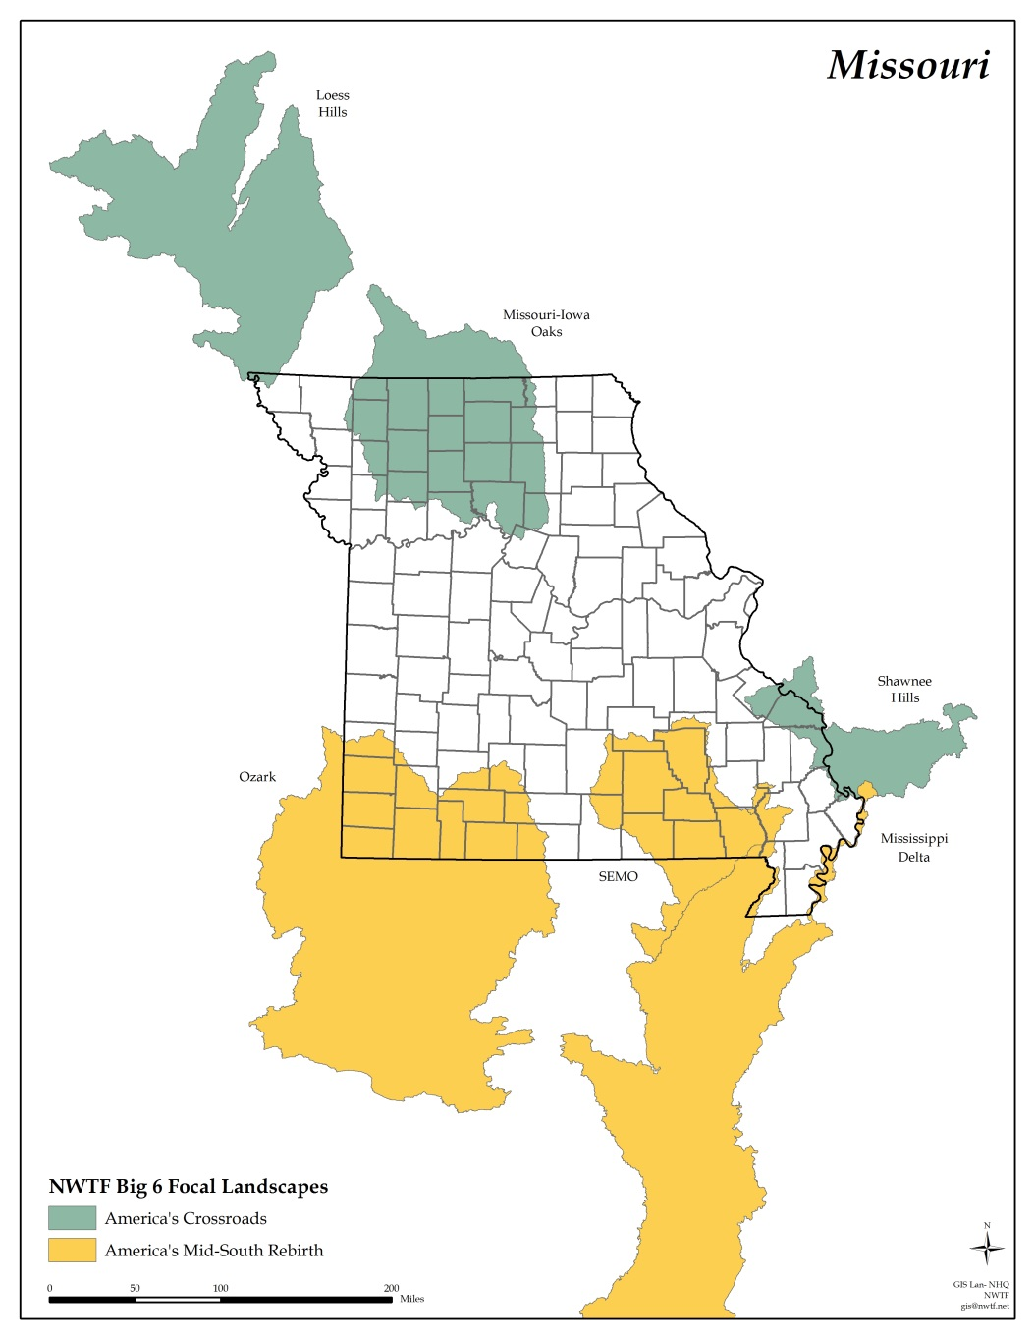

Figure 1. Map of Missouri NWTF Focal Landscapes

