For Immediate Release
For more information, contact Pete Muller at (803) 637-7698

Bennett Receives National Award from NWTF
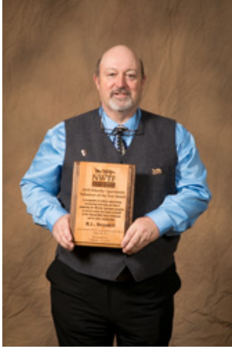
(click photo for higher resolution image)
NASHVILLE, Tenn. — R.L. Bennett’s devotion to providing outdoor opportunities to individuals with mobility impairments and special needs earned him the Wheelin’ Sportsmen Volunteer of the Year Award from the National Wild Turkey Federation.
“I feel very humbled and honored to now be in the ranks of the great volunteers for the NWTF that have been recognized and honored in the past,” Bennett said. “I hope I can continue to work and serve our Wheelin’ Sportsmen, to bring joy and smiles to their faces, as they too enjoy our great outdoors.”
Bennett, of Nixa, Missouri, accepted the Wheelin’ Sportsmen Volunteer of the Year Award during the 43rd annual NWTF Convention and Sport Show. Mossy Oak is the official convention sponsor.
Bennett has worked tirelessly in promoting outreach events throughout his nearly 25 years of volunteer service to the NWTF. He’s had a hand in the coordination of the annual Day at the Range event at Bois D’Arc Conservation Area, an event that usually welcomes more than 250 handicapped individuals for a day of outdoor activities.
An annual deer hunt for those with mobility impairments, also hosted at Bois D’Arc CA, has benefitted from Bennett’s efforts as well. He works with fellow committee members to scout the property, place blinds and recruit mentors, all in an effort to provide the hunters a most enjoyable experience.
“R.L. is committed to the NWTF’s Save the Habitat. Save the Hunt. initiative, dedication his time and efforts to the Wheelin’ Sportsmen program,” NWTF CEO Becky Humphries said. “Without his, and countless other volunteers’ devotion, many would not get to enjoy our great outdoors.”
The NWTF Wheelin’ Sportsmen program provides all people with disabilities opportunities to enjoy the outdoors. NWTF chapters host Wheelin’ Sportsmen events across North America to help participants gain a sense of independence by learning to stay active in the outdoors on their own.
About the National Wild Turkey Federation
When the National Wild Turkey Federation was founded in 1973, there were about 1.3 million wild turkeys in North America. After decades of work, that number hit a historic high of almost 7 million turkeys. To succeed, the NWTF stood behind science-based conservation and hunters’ rights. The NWTF Save the Habitat. Save the Hunt. initiative is a charge that mobilizes science, fundraising and devoted volunteers to raise $1.2 billion to conserve and enhance more than 4 million acres of essential wildlife habitat, recruit at least 1.5 million hunters and open access to 500,000 acres for hunting. For more information, visit NWTF.org

National Wild Turkey Federation
770 Augusta Rd., Edgefield, SC 29824

